The Ring in Karlsruhe – March 2018

Michael Marr

Having attended the interesting Denis Krief production of Wagner’s Der Ring des Nibelungen as part of our Society trip to Karlsruhe in 2011, I was looking forward to this new 2018 production. But looking forward with some apprehension, as the four operas had been entrusted to four different directors. It was called “Der Ring der Vielfalt” – The Ring of Varieties and conducted, as in 2011, by Justin Brown.

Das Rheingold – directed by David Hermann.

Hermann’s original intention was to have appear, for each Leitmotiv, the object or person relating to it. This turned out to be too complicated and thus impractical. So, instead, he decided to preview the whole Ring story in Das Rheingold:
- In the first scene, Erda appears to the Rhinemaidens (this was of significance later);
- In the second scene, we see Siegmund and Sieglinde interacting with Hunding, the death of Siegmund and the appearance of Brünnhilde;
- In the third scene, a Siegfried slays the dragon which appears when Alberich dons the Tarnhelm;
- In the final scene, we see Hagen, Gunther and the other characters from Die Götterdämmerung. Loge lights the pyre for the fiery end of Siegfried. Finally Brünnhilde tosses the golden Ring into the waters of the Rhine where it is caught by Erda who returns it to the Rhinemaidens.

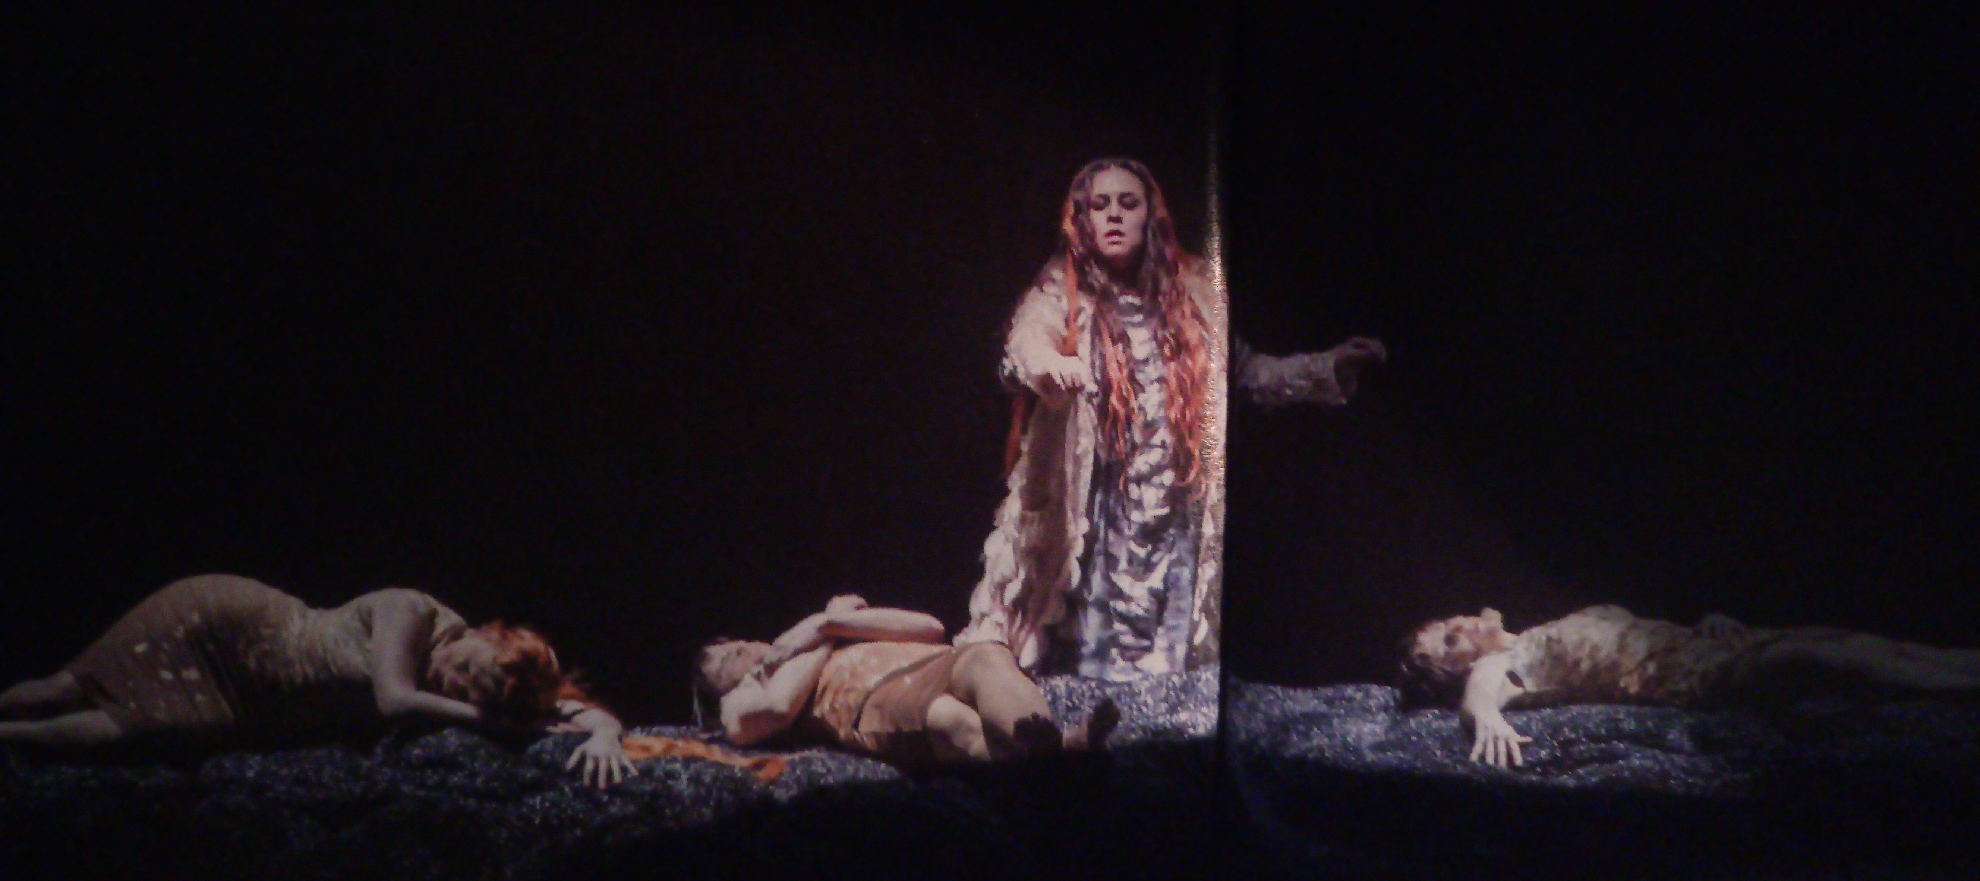

These previews of the stories of the other three Ring operas were done by silent actors, apparently visible only to Wotan (and of course the theatre audience), warning him of the fate which awaits him and Valhalla.

Meanwhile, as this parallel action was taking place above and at the back of the stage, we enjoyed an excellently sung and acted Rheingold. The Rhinemaidens wore glittering golden costumes and performed on an abstract set. In the other scenes, the sets were modern, as were the costumes worn by the singers. Judging by the prolonged applause the audience obviously understood and enjoyed the performance.

Die Walküre – directed by Yuval Sharon. He is a modern, avant-garde director who assisted Achim Freyer in his 2010 Los Angeles Ring. His idea of the Gesamtkunstwerk was to integrate modern technologies into this interesting production.

His set was very shallow and plain, just a wall with three small doors. These doors opened occasionally to reveal singers, actors or video scenes. An interesting innovation was to see the characters’ shadows appearing on the wall and showing their true feelings – while Siegmund and Sieglinde were apart singing on the stage, their shadows embraced in the background.

The whole wall lifted sporadically to show a moving staircase. Wotan could be seen wandering aimlessly up and down or projected behind it.

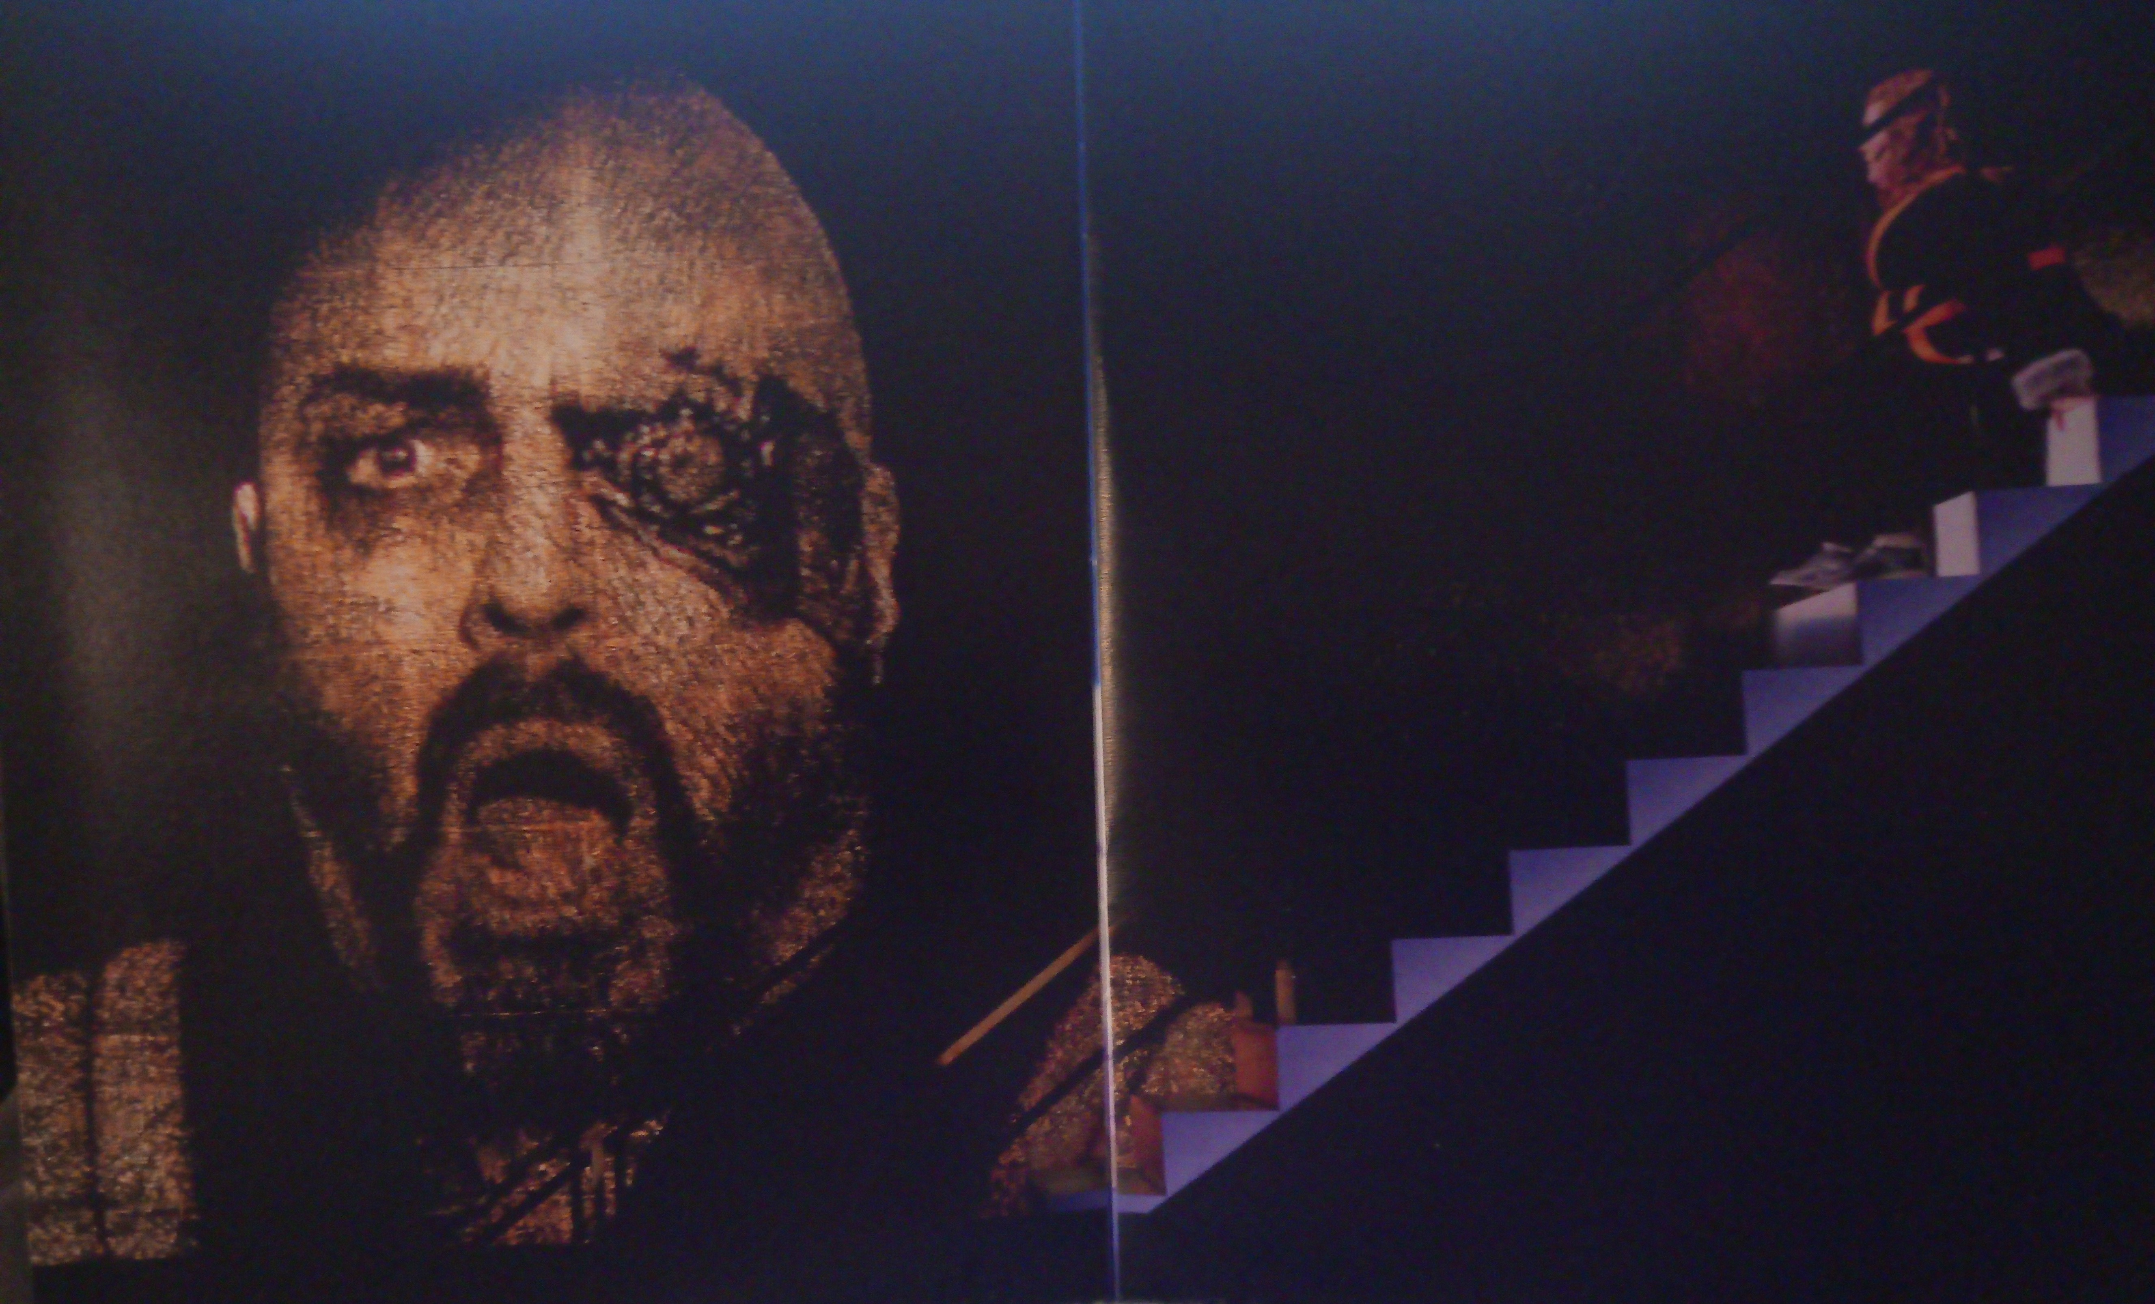

There was more video in the final scene, with the Wotan’s daughters, dressed in orange ski suits, flying over an icy mountain range, with some of them on motorcycles. They finally appeared live on stage in a snowstorm, by parachute. The set consisted of a simple assembly of white slabs, representing an Arctic scene.

Before Wotan lit the fire surrounding Brünnhilde he encased her in a block of ice! Given the ferocity of the flames, I doubt if the ice would last, as was intended by the director, to preserve her for 18 years until she is released by Siegfried in the next opera.

Siegfried – directed by Thorleifur Örn Arnarsson.

For this opera the director emptied the props department and cluttered the stage with, we are told, 500 objects of no particular significance. He also had the costume department working overtime, with Siegfried appearing in a number of different costumes, ranging from a dinosaur to Superman to a fluorescent skeleton. A young man trying to find his identity, perhaps. The Wanderer was dressed as Gandalf from Lord of the Rings and Mime could have been mistaken for the Gollum. With so much spent on the above, there was little available for the scenery, which was unchanged through the three acts - it could have been the inside or the outside of a baroque castle.

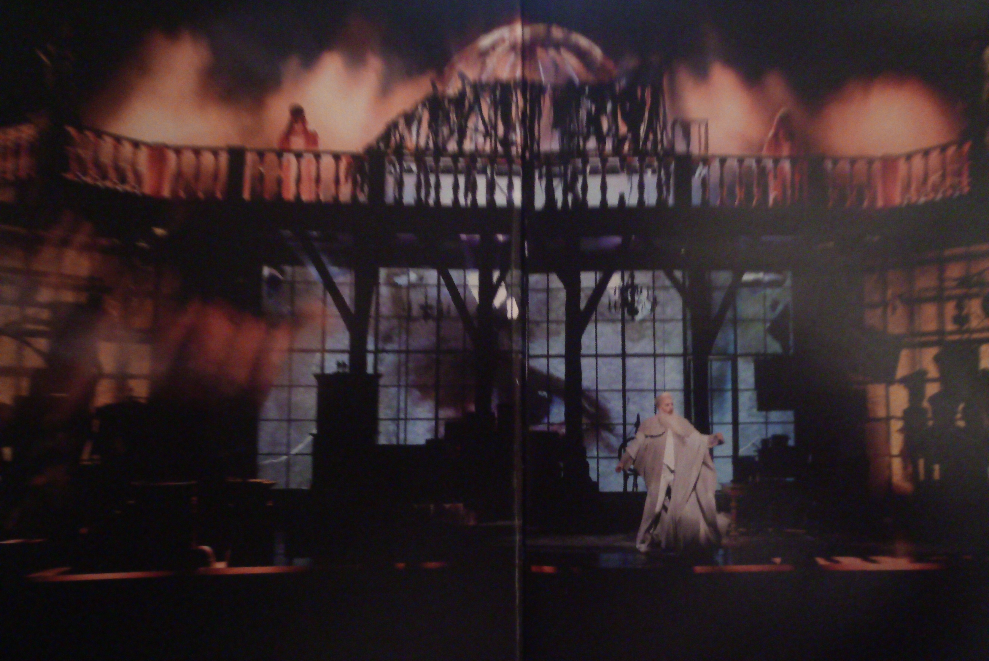

The action was basically in line with the original story. But Siegfried plays tunes to the Woodbird on a seriously out-of–tune piano, then on a garden hose. After he forges his sword Nothung, he splits the anvil with such force that he is left (unintentionally?) with a bent sword. After that he only uses it sparingly - his fight with the dragon Fafner is unconvincing; he breaks Wotan’s spear over his knee; he kills Mime not with his sword but by swapping the beakers and thus poisoning him.

The final act was the source of some anxiety in the audience. Siegfried sang about the figure he found on the rock, discovering it was a woman, removing her armour etc. But there was a problem – Brünnhilde was missing. Had she missed her cue (as happened to Wotan in Leipzig in 2016)? Was she indisposed and no cover available? Well, as we all know it’s not over until a lady of a certain size sings – and so it was. Just at the last moment Brünnhilde appeared at the back of the stage. She was worth waiting for, as she filled the role 150%, both in her size and in the power of her voice, always singing, never shouting. A beautiful ending to a puzzling production.

Götterdämmerung – directed by Tobias Kratzer.

The most memorable element of this production was that most of the singers spent their time prancing about the stage in their underwear. If they were wearing their regular clothes, they soon shed them to reveal what the whiter-than-white garments they had on underneath.

The curtain opened to show the directors (fully clothed) of the three previous operas on stage, sitting on film directors’ chairs, with their backs to the audience. They are looking at a cinema curtain displaying “THE END”. Their work is done, they know what will happen next, there is nothing they can do except observe inevitable ending. But when they turned around and started singing, they were revealed to be the three Norns!

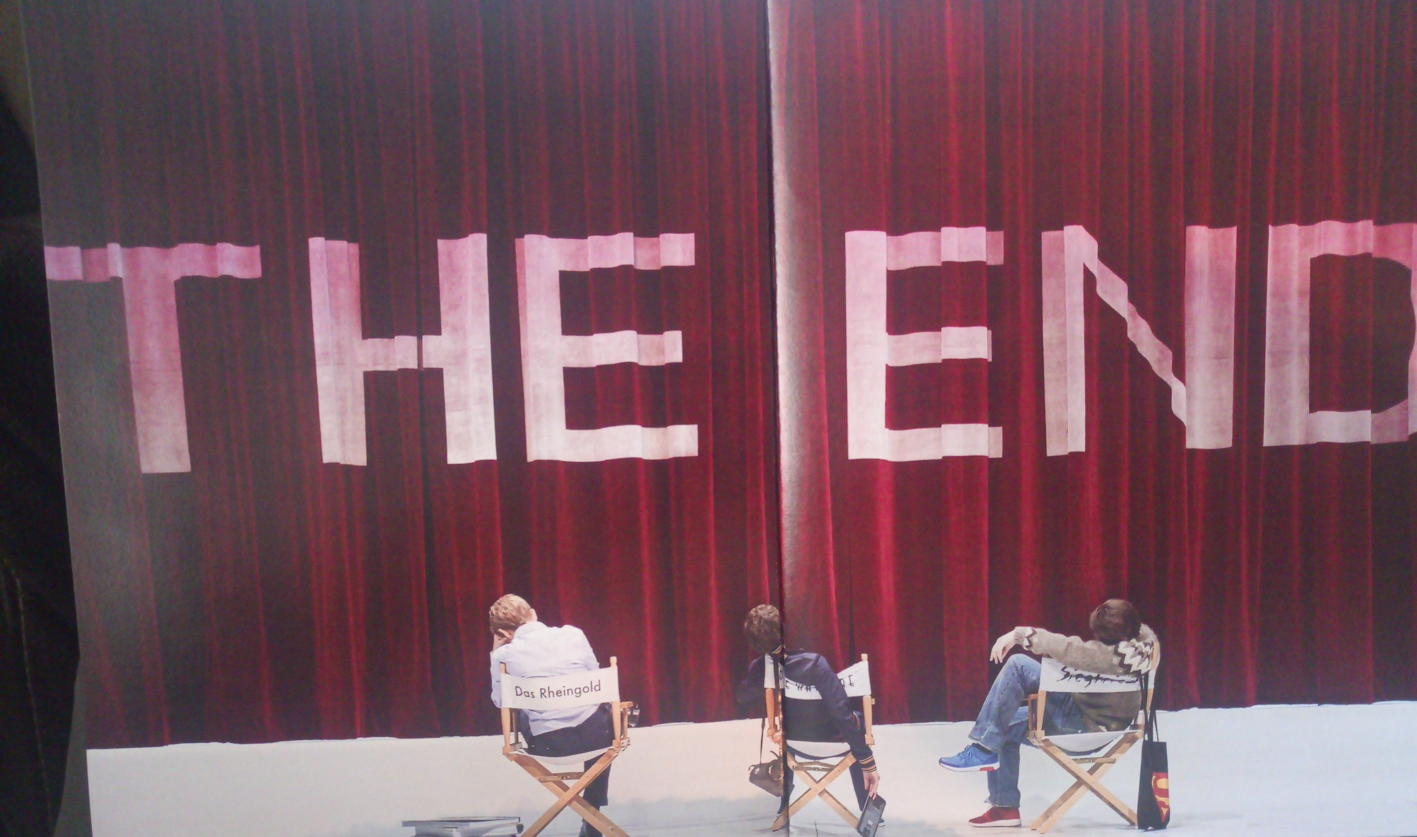

Then Brünnhilde and a very youthful-looking (remember, he was supposed to be only 18) Siegfried sang their hearts out, on her rock (actually a honeymoon suite in a hotel) with the three directors/Norns filming the event on the brightly-lit stage.

The next scenes with Gunther, Hagen et al were more sombre. The bare, dark stage was surrounded by mirrors. Again the three “directors” appeared on stage and filmed (we could see some of what they were filming projected onto the scenery) the action. A live horse appeared and stood motionless on stage. Why? Grane? Gunther, leading Brünnhilde, travelled on the bonnet of a large Jeep. Hagen as usual killed Siegfried and Gunther but also Gutrune who, with a last effort, herself stabbed Hagen to death.

In the end, Brünnhilde refuses to accept her fate. She argues with the directors – they show her Wagner’s score, she seizes and burns it. Finally we see Siegfried reappear in the honeymoon suite which he had left earlier when going on his quest. He comes in backwards and, reversing his movements from when he left Brünnhilde, ends up on the bed with her. THE (HAPPY?) END

The Music. The excellent orchestra was conducted by Justin Brown, the Music Director. The singing was, without exception, outstanding. Most of the singers were members of the Karlsruhe ensemble, supplemented by a few guests. Of these, only two names were familiar to me –
- Daniel Brenna, Siegfried in Gotterdämmerung, whom I saw as Siegfried in Dijon and who appeared more recently in the Washington, DC Ring production.
- Heidi Melton, who sang in Rings in San Francisco (Sieglinde, 3rd Norn) and the Met (3rd Norn). In Karlsruhe she sang all three Brünnhildes, to great acclaim.

Finally, I must mention one member of the Karlsruhe ensemble: Australian mezzo Katharine Tier. She sang Fricka (Das Rheingold), Fricka and Waltraute (Die Walküre), Erda (Siegfried) and finally Waltraute, the 1st Norn and Flosshilde, as well as acting as Director David Hermann (Götterdämmerung). Her engagement in Karlsruhe is ending and I am looking forward to seeing and hearing her in other opera houses around the world in the future.

In Summary. The Karlsruhe production of Der Ring des Nibelungen was musically excellent, the staging was innovative, the audience was enthused. I would certainly recommend it, especially to someone who has been to a few Rings before and is familiar with the original story and the music.

LEIPZIG MAY 2018
PAUL MAGNIER

Leipzig looked very well in the Spring sunshine on our recent visit to attend the Oper Leipzig Ring Cycle. The cycle was held on consecutive evenings, a bonus in some ways (spectators) but a major problem in others (singers not getting enough rest). The cycle included singers with multiple roles.

The city and surrounding area continues to thrive and there has been considerable building work done in the city since 2016.

There will be a Ring Cycle in May 2019 over four days and is bookable now.

A mini Richard Strauss cycle will be done just before the 2019 Ring of Rosenkavalier, Salome and Elektra.

There were dancers on stage for most of the scenes. I hated this. They added nothing to most scenes and in fact were very disruptive. The director is a former ballet dancer, which accounts for the monstrously intrusive presence. They added some interest in Rheingold and the beginning of the last scene of Gotterdammerung.

The orchestra were variable. The early horn entry in Rheingold was botched and one spent the rest of the cycle hoping the same would not happen again. Ulf Schirmer the conductor was heavily criticised by some of our party. Members comments included “not a Wagner conductor” and “Andris Nelsons would not put up with it” He compensated with a tremendous performance in Gotterdammerung.

Some singers had multiple roles. Tomas Pursio was Wotan in Rheingold, Alberich in Siegfried and Gunther in Gotterdammerung. He was stretched at times and in the process of ruining a fine voice.

Runi Brattberg was Fasolt in Rheingold, Hunding, Fafner in Siegfried and Hagen. A local favourite he was wildly applauded at each curtain. I found him unsympathetic.

Claudia Huckle as Erda was very fine. A striking woman with a lovely voice, she had Wotan at her knees in Rheingold and more than held her own in Siegfried.

Iain Paterson, a Bayreuth regular was an excellent actor and a very good Wotan.

The Siegfried in Siegfried was Christian Franz. He was inadequate for the role. He was barely audible in the first Act, improved marginally in the second and just about held on in the third act. In retrospect he was not trying very hard until the last act. We heard him as Siegfried in Bayreuth in 2004 when he was excellent. In Budapest in 2016 he was quite good as Siegfried. In that cycle he also sang Loge and Siegmund. Oversinging has obviously contributed to his marked decline.

He was comprehensively outsung by Catherine Broderick, a UK singer, new to me who showered us with some glorious and consistent sounds. Her size restricted her acting to semaphore-like movements.

The positive elements of the dancers was during the Niebelheim scene in Rheingold when they formed the dragon and toad, the tree with golden apples at the end of Rheingold and in Gotterdammerung when the drove the Gods off the stage by continually jumping on their backs!

Christine Libor was Brunnhilde in Walkure and Gotterdammerung. I found her excellent, with a strong presence in both opera’s and glorious in the finale.

The Immolation Scene was very fine and certainly the highlight for me and most of our party. It is the most important section of the Cycle and if not sung well and sympathetically presented then all that went before is negated.

The set for Gotterdammerung consisted of large pillars with a walkway at the back. Modern furniture was a feature with a white grand piano.

Catherine Libor was tremendous, singing with a lovely tone and acting very finely and Thomas Mohr was a rather stolid Siegfried in Gotterdammerung but could sing the role. If that last comment was somewhat negative, it was a contrast to the dire singing we heard from the Siegfried of the evening before.

The actor playing the role of Grane was excellent. He bore the dead Siegfried on his back during the Funeral March music across the elevated walkway at the back of the stage which looked dignified and moving.

Hagen recoiled at the shock he received from the elevated hand of Siegfried when he tried to take the ring. He remained traumatised at the side of the set subsequently and made a poor attempt to struggle with the Rhinemaidens.

Siegfried was wheeled in on a grand piano, Brunnhilde climbed up and lay beside him. Grane loaded all of Brunnhilde’s armour under the piano. He appeared to help set the fire and became part of the pyre. The set’s pillars collapsed during the final scene and the piano on fire became the focus. Hagen failed and the Rhinemaidens rescued the ring during the general collapse. Ecstatic applause resulted at the final curtain. A great ending to an enjoyable trip.

